Heritage Statement
Heritage Statement:
Whilst the site is located with the conservation area it is not within the setting of any listed buildings. It is fully surrounded by modern development and as a result consideration of the significance of any of these heritage assets is not necessary.
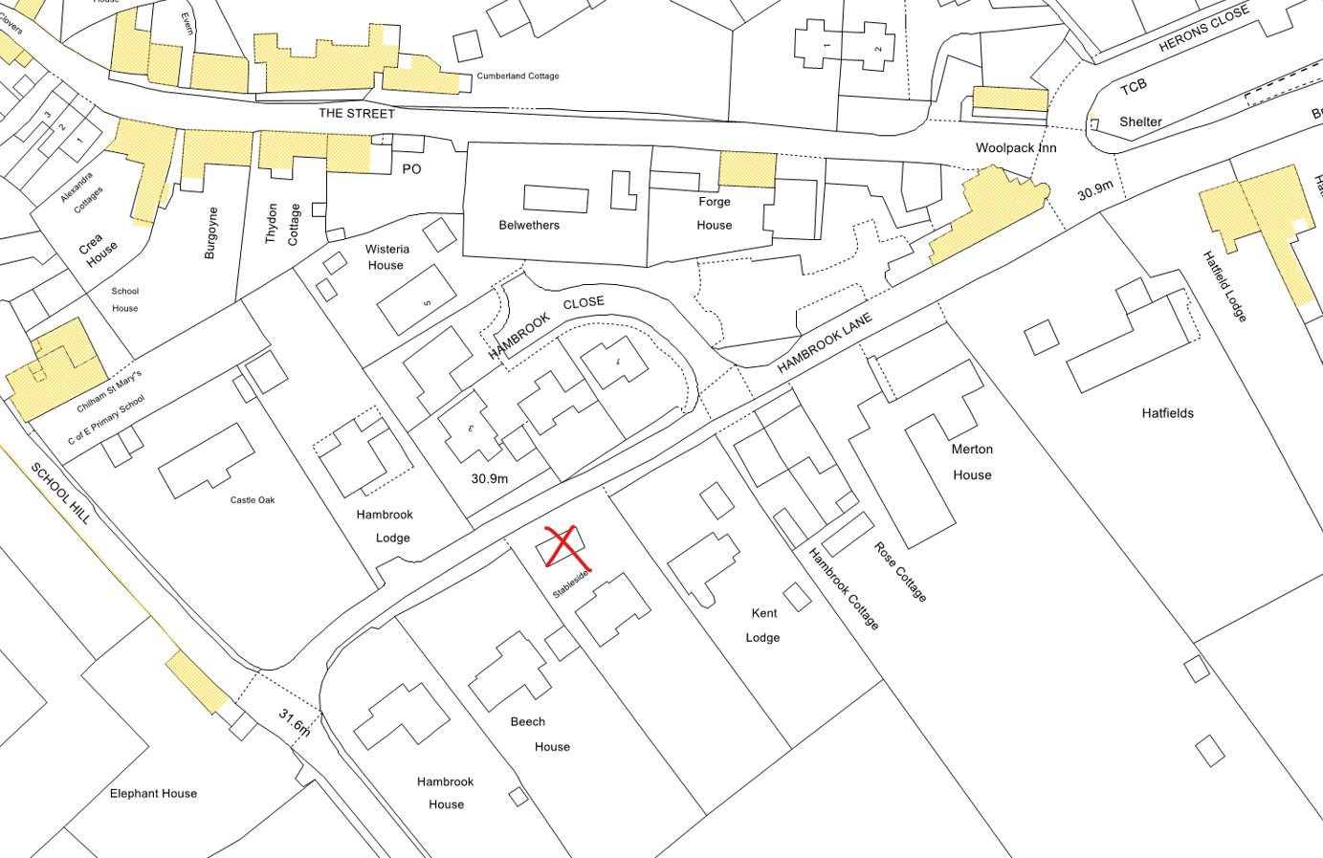

The existing structure is set near to the public highway, however the only alteration that will be visible from a public viewpoint will be the small single window proposed to the eastern elevation. All other alterations have been specifically designed to be located to the ‘inside’ of the side in order that they will have no impact on the Conservation Area. As luck would have it this also is the right side to benefit the solar panels. All of the, limited, alterations proposed are consistent with the established style, materiality and established domestic use of both the immediate building and the surrounding area. Accordingly, it is considered that there will be no harmful impact on the Conservation Area.

