HERITAGE STATEMENT

Little Singleton Barn, Great Chart, Kent TN26 1JS

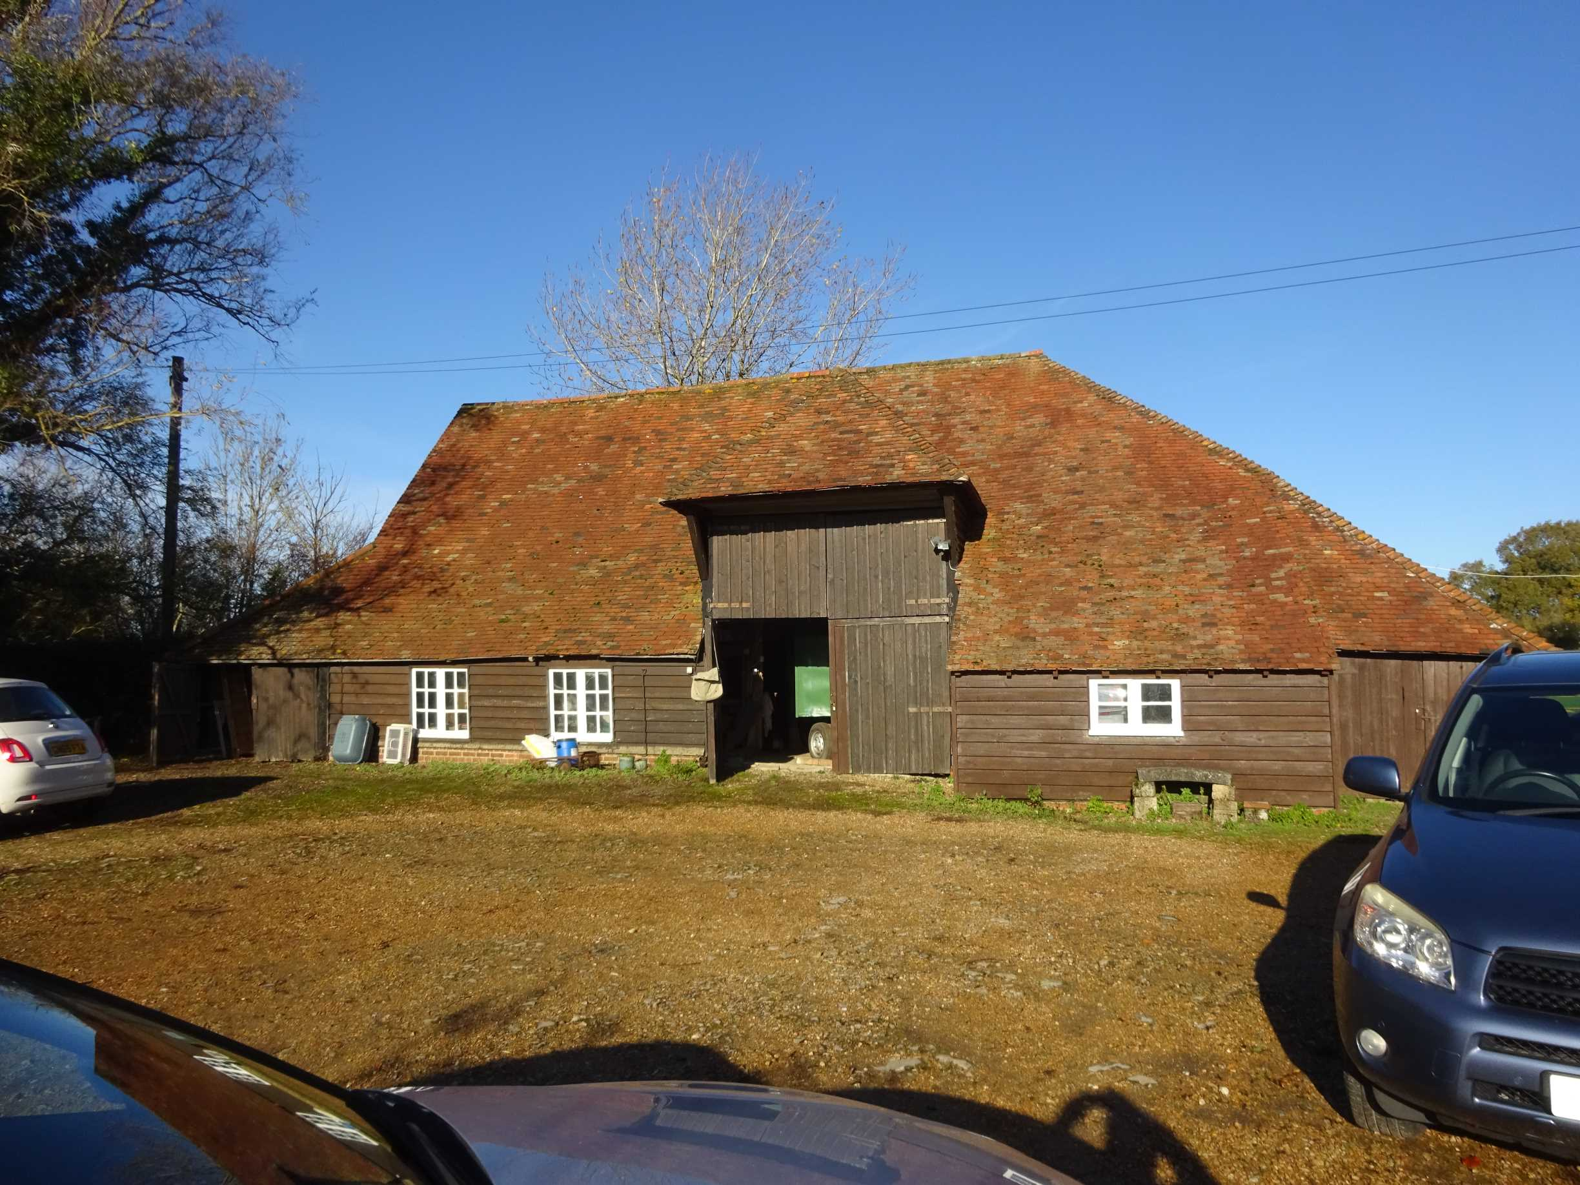
South elevation

INTRODUCTION

Little Singleton Farmhouse is listed Grade II*. The Barn is a salient element in the setting of the Farmhouse both from within and without. The demises have latterly been separated so the Farmhouse no longer has any management of the Barn whilst the Barn’s condition is deteriorating to incipient ruination.
This application is made by the owners of the Barn who are seeking an Optimum Viable Use.

SIGNIFICANCE

Intrinsic significance (Refer to Drgs 1.16 and 1.17)
An analysis by Canterbury Archaeological Trust is appended. We summarise its findings:
- The core structure is late medieval, purpose built in this location
- The core structure survives sufficiently to conjecture some authentic restoration.
- The outer structures to this core were added in the later 19th century, it was never an aisled barn.
- The fabrics of the roof, barn doors and much of the outer walls are of 20th century construction
CAT concludes that sufficient remains of the original barn for its preservation as a non-designated heritage asset but infers that the present Barn falls short of the criteria for individual listing.

Curtilage significance
The heritage value of the Barn as a curtilage structure is arguably greater than its intrinsic significance. Its core is coeval with its Grade II* host, Little Singleton Farmhouse (list entry1071474:1967). The Barn is thus a salient element in the agricultural ambience of the complex.

STRUCTURAL CONDITION
A structural report from The Morton Partnership is appended. We summarise its findings as follows:

- The structure is in poor and deteriorating condition. Urgent attention is required.
- The process of providing a contiguous slab/foundation will undermine existing footings.
- The present distortions in the core fabric should be redressed. This process can be carried out in-situ through a system of temporary jointing and bracing.

PLANNING POLICIES
It is proposed that Optimum Viable Use as defined in NPPF 202 is as a single dwelling, i.e. a change from Use Class B8 to C3(a). Ashford Borough Council have confirmed (21/00034/PRE) that that would be compliant in principle with their Local Plan, subject to compliance with the detail prescriptions set out in their Reuse of Agricultural Buildings (undated). Clause 2.2.7 pertains; ‘It is recognised that if a Listed Building [in this case curtilage structure] is in a poor state of repair and the only way to safeguard its future is through conversion then, provided the changes proposed preserve the overall integrity of its character, it should be acceptable’ A detailed evaluation against guidance is given below.

DESIGN PARAMETERS

The medieval core
The medieval core is considered sacrosanct. It is to be wholly retained, restored, expressed and delighted in as a quality of the new residence. The designs are arranged to avoid any cutting through of tie beams etc, and all divisions will be inset to the frame. Loss of original fabric will be limited to cutting through the sole plate where internal ground floor circulation demands.

External form
The existing form of the barn will be effectively retained. Aberrant features such as the modern south outshot to the east of the barn doors will be removed and the roof tiling will be correctly re-laid in Kent peg tiles with bonnet hips. All will be encompassed within the existing ridge line and footprint after regularisation of structural distortions.

Landscaping and boundaries
The setting of the Barn in relationship to Little Singleton Farmhouse is critical to the ambience of the heritage asset. To prevent any signal of domesticity the south and east boundaries are drawn tight to the Barn with right of access for maintenance only. The west boundary, to Goldwell Lane, is a naturally formed with trees and hedgerow. The garden boundary will be ‘soft’ formed with native hedging.

Consideration under Ashford BC, The Reuse of Agricultural Buildings
Clause 2.2.7 pertains; ‘It is recognised that if a Listed Building [in this case curtilage structure] is in a poor state of repair and the only way to safeguard its future is through conversion then, provided the changes proposed preserve the overall integrity of its character, it should be acceptable’

Guidance 1
Not applicable
Guidance 2
Exceptional circumstances apply
Guidance 3
As discussed in this Statement
Guidance 4
Specialist report provided
Guidance 5
Two of the four bays including the most eventful with the threshing floor and hipped east end, will remain open to their full height.
Guidance 6
The aberrant modern outshot to the south elevation will be removed with benefit to this salient elevation
Guidance 7
The barn doors will be replaced in facsimile and the north doors will be openable to cover an interior glazed screen. There is no net increase in door and window openings, all new joinery will be in vernacular style.
Guidance 8
See above
Guidance 9/10
There will be a single additional roof light, this and replacement lights will be of heritage, inset type.
Guidance 11
SW weatherboarding with stained finish to prior approved sample
Guidance 12/13
Not applicable
Guidance 14
Compliant access is provided
Guidance 15
It is clearly neither functionally possible nor desirable to provide car parking within the Barn.
Guidance 16
Not applicable
Guidance 17
See Boundary Treatments

IMPACT ASSESMENT
(Refer to drawings 1.14B and 1,15B)

A massive intervention is required to provide structural stability and a serviceable floor slab to secure the Barn’s future. This will include underpinning at the feet of the core frame posts, strip footings around the perimeter and a contiguous floor slab, we address the implications as follows:

Impact on historic core
The impact upon the historic core will be positive. Underpinning will halt the ongoing process of deformation and provide a secure basis for restoration.
The engineers’ report advises that the process of repair and restoration could be carried out ‘in-situ’, i.e. by cradling and jacking up the frame rather than dismantling.
Impact on internal secondary fabric
Internal secondary fabric affixed to the historic core must be removed to enable its restoration. This fabric, including the inserted floor is of such makeshift carpentry that it could not be subsequently reinstated and anyway would conflict with the proposed new use. All must be wholly removed.
Impact on external secondary fabric
The external walls and barn door frames are roughly carpentered and extensively degraded by rot and distortions. They cannot realistically be realigned and repaired in-situ through the process of forming the perimeter footings and also require to be brought up to thermal performance required by Building Regulations. It is proposed that they be wholly rebuilt to match the existing external appearance of weatherboarding over a brick spandrel.
Impact on roof structures
To avoid the issue of ‘demolition’, the 20th century roof structure over the historic core can be retained and adjusted back to register in-situ. The ephemeral structures of the outer slopes will need to be rebuilt to fit correction of the manifold distortions
Impact on external appearance
There will be a significant benefit to the salient south elevation through removal of the existing, aberrant projection to the east of the barn doors.
(The south elevation might be made wholly window free, but ABC have indicated their preference for windows rather than a rooflight to light and ventilate the internal arrangements).
Restitution of weatherboarding over brick plinths entails no deleterious impact upon the appearance of existing elevations.

CONSIDERATION UNDER NPPF 202
‘Where a development proposal will lead to less than substantial harm to the significance of a designated heritage asset, this harm should be weighed against the public benefits of the proposal including, where appropriate, securing its optimum viable use’.
We identify the harms and public benefits as follows:

Harms
- Change to existing ambience
- Total loss of internal secondary fabric
- Replacement of external secondary fabric in approximate facsimile

Public benefits
- Providing an Optimal Viable Use for securing the Barn as a salient curtilage structure to Little Singleton Farmhouse. We emphasise this benefit as the existing condition is approaching ruination.
- Restoration of the historic medieval frame, albeit for private delight.

