Location: | Woodland Vale, Nickley Wood Road, Shadoxhurst, Ashford, Kent, TN26 1LZ
Description: | Stationing of 2no additional mobile homes and 2no touring caravans, relocation of site access (part retrospective)
Introduction

The application site is a Gypsy and Traveller site that fronts onto the northern side of Nickley Wood Road, located outside of the built confines of Shadoxhurst in the countryside for the purposes of the Development Plan. The site also falls within the Shadoxhurst Woods landscape character area. The majority of the site is hard surfaced with a previously wooded open green area located to the rear of the site. Although marked as part of this application, it will remain undeveloped and will be fenced on and replanted. The proposed area for the mobile homes is already laid to hard/sealed surface as can be seen from the photo below.

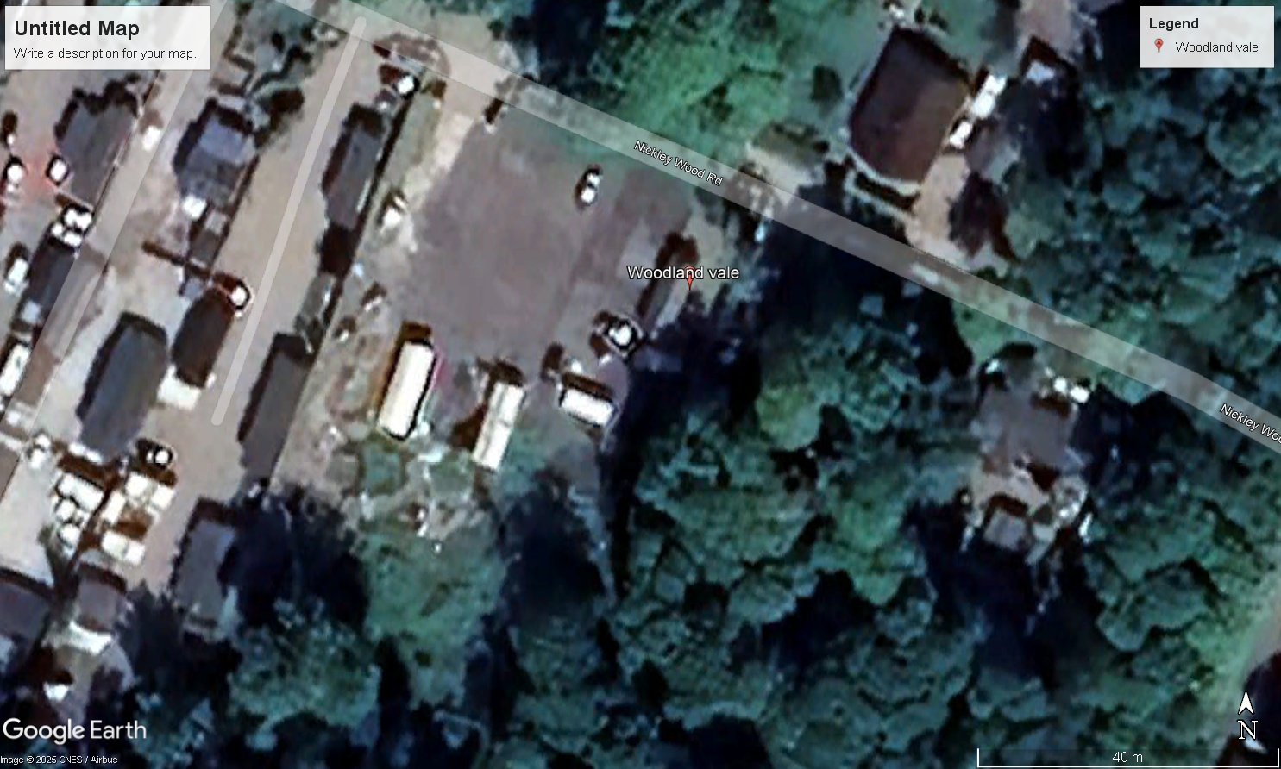

The site has approval for the siting of 3 no. mobile homes and 3 no. touring caravans under application reference 13/00495/AS. Nickley Wood Road is characterised by detached bungalow properties in substantial plots and several Gypsy and Traveller sites with numerous pitches on them. Immediately to the West of the site is the ‘Three Oaks Drive’ which was approved under 16/01232/AS.

Proposal

Stationing of 2no additional mobile homes and 2no touring caravans, relocation of site access (part retrospective). The applicant has amended the location of the mobile homes and touring caravans within the site in order to comply with licencing requirements.

Relevant Planning History

Application Reference | Proposal | Date Valid | Application Status | Decision
19/00550/AS | Removal of existing bungalow and erection of a replacement dwelling resubmission of 18/01311/AS | 15/4/2019 | Decision Made | Refuse
18/01311/AS | Removal of existing bungalow and erection of a replacement dwelling | 03/9/2018 | Decision Made | Refuse
13/00495/CONA/AS | Discharge of conditions 5, 6 and 8 | 08/8/2014 | Decision Made | Permit
13/00495/AS | Siting of 3 static gypsy caravans | 11/6/2013 | Decision Made | Permit
90/01313/AS | Renewal of temporary planning permission for private gypsy site. 3 mobile homes/caravans change from temporary to permanent permission and area of hardstanding ancillary to use of site | 17/9/1990 | Decision Made | Refuse

Planning Policy

The Development Plan for Ashford borough comprises:
- the Ashford Local Plan 2030 (adopted February 2019),
- the Chilmington Green AAP (adopted July 2013),
- the Wye Neighbourhood Plan (adopted March 2016)
- the Pluckley Neighbourhood Plan (adopted April 2017),
- the Rolvenden Neighbourhood Plan (adopted December 2019),
- the Boughton Aluph & Eastwell Neighbourhood Plan (adopted October 2021)
- the Egerton Neighbourhood Plan (adopted March 2022)
- the Charing Neighbourhood Plan (adopted July 2023)
- the Kent Minerals and Waste Local Plan (2016) & the Kent Minerals and Waste Early Partial Review (2020).

The relevant policies from the Development Plan relating to this application are as follows:
Ashford Local Plan 2030: SP1 SP6 ENV1 ENV3a ENV4 ENV9 HOU16 HOU17

Supplementary Planning Documents

Landscape Character SPD 2011
Residential Parking SPD 2010
Sustainable Drainage (SuDs) SPD 2010

National Planning Policy Framework 2023
Planning Practice Guidance Planning Policy for Traveller Sites 2023

The national policy position comprises the National Planning Policy Framework (NPPF) and Planning Policy for Traveller Sites (PPTS December 2023).
Together they provide national guidance for Local Planning Authorities on plan making and determining planning applications for Gypsy and Traveller sites. Both documents state that applications for planning permission must be determined in accordance with the Development Plan unless material considerations indicate otherwise.

The PPTS states that if a local planning authority cannot demonstrate an up–to-date 5 year supply of deliverable sites, this should be a significant material consideration in any subsequent planning decision when considering applications for the grant of temporary planning permission.

Assessment Traveller Pitch Need and 5 Year Supply Position

The adopted Local Plan 2030 sets out a dual approach to traveller site/ pitch provision. The Council is still in the process of preparing a Gypsy and Traveller Local Plan, with the suggestion that further site allocations will come forward. To inform the preparation of the Gypsy and Traveller Local Plan, the Council commissioned an update to the GTAA in 2018 (which was subsequently updated in 2019). The survey work was carried out in conjunction with other authorities across East Kent. The GTAA provides a robust assessment of pitch need and supply across the Borough. This identified a ‘cultural’ need for 74 pitches and a ‘PPTS’ need of 49 pitches for the remainder of the plan period to 2030.

Therefore, the Council cannot currently demonstrate a 5-year supply of deliverable sites. There is an unmet need for sites within the Borough and no Local Plan allocated sites are available. Taking into account the lack of 5 year supply of Gypsy and Traveller sites within the Borough, and the fact that the site is not located within any protected areas as highlighted in paragraph 11 of the NPPF, it is appropriate to consider that paragraph 11 of the NPPF is engaged and that there is a presumption in favour of sustainable development in this instance.

Principle

It is a function of the Local Planning Authority to allocate appropriate sites for the Gypsy and Traveller community. The Council has previously acknowledged that it remains the case that the Council is unable to identify a supply of specific deliverable sites sufficient to provide 5 years supply of sites against their locally set targets as required in paragraph 10a of Planning Policy for Traveller Sites.

As such, for the foreseeable future, specific deliverable sites would not be available to be supplied to meet an identified need. This is a material consideration in the planning balance. As such, there is a reliance on windfall sites that meet the criteria of HOU16. Development Plan Policy seeks to focus development at accessible and sustainable locations and to protect the character and appearance of the countryside and in particular National Landscapes (previously known as AONB's). As such, the principle of granting planning permission for new sites to accommodate Gypsy and Traveller accommodation will only be permitted outside of allocated sites subject to criteria a) to j) of Ashford Local Plan policy HOU16.

Gypsy and Traveller Status Information regarding the Gypsy and Traveller status of the applicant and his immediate family have been accepted in the original application and does not need to be re assessed. The additional mobile homes and touring caravans are for immediate family members of the applicant, and the council should be satisfied that their Gypsy and Traveller status is correct.

Sustainability of application site

Although there are no local services and facilities which can easily and safely be accessed from the site via foot or by bicycle. The Council should recognise that a range of appropriate services and facilities in Hamstreet, Shadoxhurst and the urban areas of Ashford are within an easy car ride of the application site. It is also important to note that the site has already been approved as a permanent Gypsy and Traveller site, and this application simply seeks to add 2 more pitches to the existing lawful site. Furthermore, the fact that there are already a number of permitted Gypsy and Traveller sites along Nickley Wood Road endorses the suitability and sustainability of the site. These all have access to water and power supply, and sewage disposal is via two existing cess pits. Therefore, I consider the proposal should be acceptable in terms of sustainability.

Visual Amenity

The site has been in use as a Gypsy and Traveller site for a number of years and in addition to this there are a number of Gypsy and Traveller sites in the immediate vicinity of the site. Therefore, the presence of mobile homes and touring caravans off Nickley Wood Road is not an alien or incongruous feature within the locality. The site has been predominately hard surfaced, and we must now address the rear of the site.

The rear of the site and the site as a whole was subject to an injunction back in 2024. Works were halted immediately but the injunction was granted across the whole land leaving the owner unable to complete the site so is suitable for him and his family. This application seeks to address the front portion of the site whilst also suggesting that the rear site subject to the tree removal, be landscaped to suit all parties.

The initial request was for the owner to replant in excess of 400 trees which is impossible and the land having been assessed would never take that many trees. This is way in excess of what was there previously. The area to be replanted will be completed with 100 trees of the Council’s choosing and will remain fenced off from the main residential section of the site. There will be a wooden five bar gate for access to maintain only. The Council’s fallback is that the injunction remains on the land so any unauthorised works can be swiftly halted.

Application reference 13/00495/AS approved the use of the site as a Gypsy and Traveller site with three mobile homes and touring caravans. The said permission limited the use of the site to the approved number of mobile homes / caravans. At present the site has 3 mobile homes and 3 touring caravans. The applicant is proposing an amended layout for the total of 5 mobile homes and touring caravans, so that the scheme would comply with licencing requirements. I consider that the proposed additional mobile homes and touring caravans in their amended layout would not appear as an over development of the site and would not appear intrusive within the locality.

The proposal would also relocate the existing access gate approximately westwards. I do not consider that the relocated access would appear substantially different to the approved access and would not appear intrusive within the street scene. Although the boundary treatment and gates are urban in style, similar have been used on other pitches within the vicinity of the site and so again, would not appear out of context. In addition, it is proposed to set the fencing back from the road and introduce landscaping in front to soften its appearance. I consider that the landscaped feature of the site would not be detrimentally less than what was previously approved. Furthermore, the site will be screened by the existing and proposed boundary treatment. For these reasons, in my view, the additional mobile homes and touring caravans and associated development do not appear out of context in this setting and as such, views of the development do not result in a level of visual harm that we consider would justify refusing planning permission.

Overall, I consider the development complies with policies HOU16 and ENV3a.

Residential Amenity

Given the limited increased intensity of use of the existing Gypsy and Traveller site by extended family of the applicant, and the modest height of the mobile homes and touring caravans, I consider that the development does not result in any demonstrable harm to the residential amenity of adjoining occupiers through loss of privacy, light, immediate outlook or by having an overbearing presence.
The site is only for occupation by a single family and so the development does not result in any undue noise and disturbance. With regard to potential noise and disturbance resulting from additional traffic associated with additional 2 pitches at the site, I consider that the additional pitches would have likely resulted in resulted in some limited intensification in traffic movements in general, but these are not considered to be significant.

Parking and Highway Safety

The proposal does result in a limited net increase in movements to and from the site but these traffic movements are not significant given the limited increase in the number of pitches and that the site is for residential use by a single family. Nickley Wood Road is a private road. Kent Highways have confirmed on another application for 4 additional pitches further along Nickley Wood Road at Millee (reference 16/01431/AS) that visibility from the junction where Nickley Wood Road joins the public highway at Church Lane is adequate and as such, there should not be any highway safety concerns with regard to the proposal. They also stated that the number of pitches on the nearby site did not give cause for concern in terms of traffic generation. For these reasons, it is my view that the development does not place undue pressure on local infrastructure or materially increase risk of road traffic accidents or significant traffic delays.

In addition, the hardstanding laid provides sufficient off-road parking to serve the development. I do not therefore consider that the development results in any demonstrable adverse highway impacts and as such, complies with the relevant policies in the development plan.

Natural Environment and Ecology

In this instance, policy HOU16 requires the development to ensure that there is no adverse effect upon the ancient woodland or local nature reserve or wildlife site. The eastern and southern part of the site falls within the Shadoxhurst Woods and Pastures (LWS). The majority of the site has been hard surfaced for a number of years, which was the case on the previous approved application. The site falls outside the Apsley/Burnt Oak Woods ancient woodland and given this and the boundary treatment between the two, the development does not have any direct detrimental impact to the flora and fauna in this area in accordance with the standing advice and guidance issued by Natural England and the Forestry Commission.

Whilst the development would result in a limited reduction in the approved landscaping on site, I do not consider that the revised landscaping would detrimentally impact the biodiversity of the gypsy and traveller site, beyond what was previously approved. The rear of the site is to be replanted and this can be secured by way of a suitably worded condition and it will remain undeveloped and will NOT form part of the residential element of the application site.

Flooding and Drainage

The application site is located within Flood Zone 1 where there is little to no risk of fluvial or tidal flooding. In terms of surface water run-off, the development has amended the large area of hardstanding on site. However, the proposal would retain the surface water drainage strategy previously considered acceptable. Furthermore, the landscaping area retained and proposed on site would allow for the hard surfaced areas to drain into these areas. The applicant has also confirmed that the site has already installed 2 Clearwater 26,000 litre cesspool tanks. These sealed tanks are emptied approximately once every 4 - 6 months. This is considered to be an acceptable arrangement for the foul water drainage at this site.

Conclusion

There is a need for Gypsy and Traveller sites / pitches in the Borough, and these should be encouraged in appropriate locations. I consider the limited intensification of an already approved Gypsy and Traveller site to be acceptable as it would not create any harm in terms of visual amenity, residential amenity or highway safety. In light of the above I am of the view that the application has satisfied that the proposed development would comply with the requirements of Development Plan policy and Central Government guidance. I therefore request that planning permission is granted.

