Unit 2C, Briar Close: Change of Use
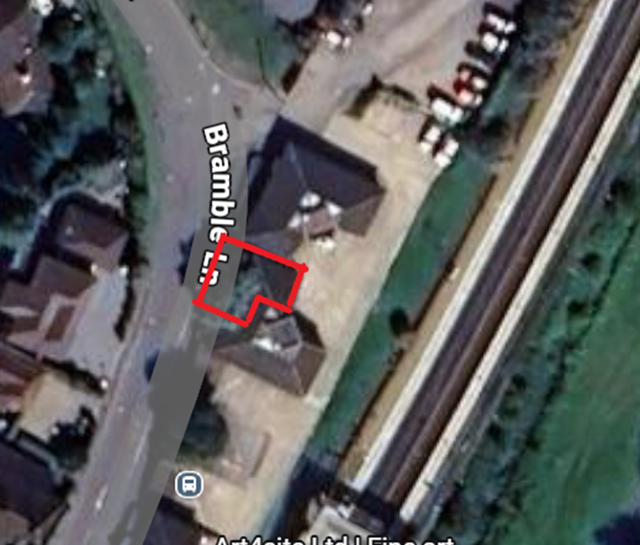

PLANNING STATEMENT
November 2025

INTRODUCTION
1.1 This short planning statement supports an application for a change of use of Unit 2C, Briar Close, Bramble Lane, Wye from offices to Beauty Salon. Both uses now fall within class E of the Use Classes Order and ordinarily a change of use would not be required. However, a restriction on the original planning permission to offices for the unit necessitates the submission of this application.
1.2 I attach the relevant application forms, site location plan and block plan together with this statement.
2.0 The Background
2.1 My client operates a Beauty Salon business (Wye Beauty) from 29 Bridge Street, Wye and has operated from the premises for the last 18 years. However, my client has been given notice to quit by her landlord and is therefore searching for a new premises in the vicinity to continue operation and retain her clientele. Here search has revealed only one premises suitable for here operation and this is Unit 2 Briar Close.
2.0 The Site
2.1 Briar Close contains a number of commercial buildings, first approved in 1970s, with unit 2 comprising office suites. My client wishes to occupy the ground floor for her business which offers a range of treatments which are briefly described below:
- Visible Age Reverse Face treatment
- Facials
- Electroysis
- Body Treatments
- Massage
- Spray tanning
Further details of business can be viewed at www.rtbs.co.uk client’s business website

2.2 The property falls within my client’s search area, is located in walking distance for most Wye residents and is ideally suited for those travelling by car with dedicated car parking serving the building.
2.3 It is located in a commercial enclave next to the station and there are no residential properties affected by the uses within the buildings.

3.0 The Need for Permission
3.1 It appears that the unit was granted permission with a restrictive permission limiting the use of the premises to the use applied for (namely offices) and for no other purpose, notwithstanding the changes to the Use Classes order and development permitted under the Town and Country Planning (General Permitted Development) Order 2015 as amended.

3.2 There is no change in use class and the proposed use, involving people regularly visiting the premises, involves an activity that has similar characteristics to the approved use.
3.3 The proposed change accords with policy Policy EMP10 which states that “In local centres and villages, planning permission will be granted for additional shopping and service provision, where proposals are of a scale appropriate to the particular centre”.
3.3 We therefore request that permission be granted for the use of unit 2C for Class Ec)ii) use

