Tim Ellis
Historic Buildings Conservation Architect
Parsonage House The Street Smarden Kent TN27 8QA
timellisarchitect@btinternet.com
Tel: 01233 770498

Heritage Statement
for
a proposed Home Bakery
Church Road, Warehorne TN26 2LL

17 November 2025

1.00 Introduction:

1.01 This application is for a detached building which will replace an existing dilapidated double garage.

1.02 The application site, edged in red, is held by separate title from my Client’s home which is The Cottage on the Green edged in blue on the site location plan. The application site fronts Church Road whilst the lane to the East faces The Green.

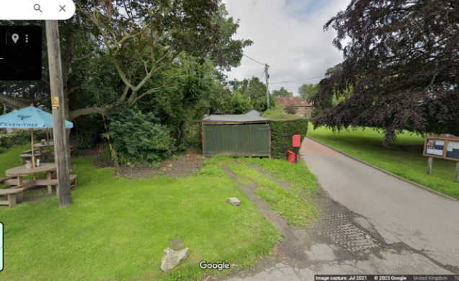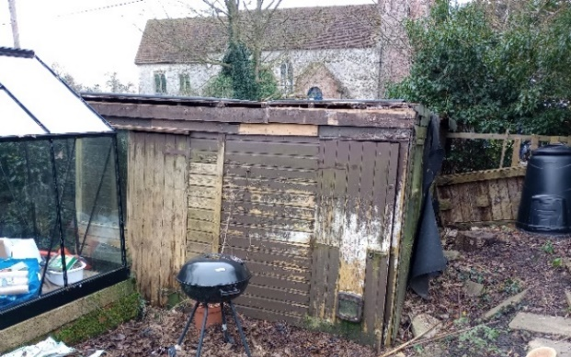
Google Street View image: Church Road frontage Rear of garage, to be replaced, and glasshouse.

1.03 To the West, the site adjoins the Woolpack PH and the pub garden is just visible in the Street View image. Whilst the road frontage is only c13m wide, the site is clearly prominent being at the heart of the village next to The Green and opposite St. Matthew’s Church.

1.04 My Client is a baker and she wishes to use the new building as a home bakery providing sweet and savoury baked goods for the gluten-free market which she will then deliver to her customers. There will be no on-site sales.

1.05 The proposals are illustrated by the drawings prepared by Olson Timber Buildings. Elevation B faces Church Road.

1.06 Pre-application planning advice (Ref: PRE/2025/00454) was received on the 20th of May 2025. The advice was favourable subject to the application being accompanied by reports/assessments; details of the reports /assessments accompanying this application are identified in paragraph 1.07.

1.07 In addition to the drawings, this Heritage Statement should be read with the following:

Archaeological Assessment prepared by KAS
Preliminary Environmental Appraisal prepared by Arbtech Consulting Ltd.
Visual Tree Assessment & Arboricultural Report prepared by Tom Bevan

2.00 Listed Building & Conservation Area Assessment:

2.01 The site is situated in the heart of the village adjacent the village pub and opposite the village church.

2.02 My Client’s house is one of a pair of cottages (Pilgrims Cottages) and hers, which is known as the Cottage on the Green, is separated from the application site by the adjoining Pilgrim Cottage.

Pilgrims Cottages were Listed Grade II on the 10th of August 1988. The List Entry Number is: 1071933.

The Listing description reads:

TQ 93 SE WAREHORNE THE GREEN (west side) 5/166 Pilgrims Cottages GV II Cottage pair. Cl8. Red brick, part painted with plain tiled roof. Two storeys and attic on plinth with 2 hipped dormers and stacks to end left and to end right. Five wooden casements on 1st floor (leaded to right) and segmentally headed wooden casement and sash to left and two wooden casements to right. Doors of 6 panels to left with flat hood on brackets, and glazed to right with sidelight and flat hood. Catslide outshot to rear.
2.03 The adjoining Woolpack Inn is also Listed Grade II, again on the 10th of August 1988. The List Entry Number is: 1185431.

The Listing description reads:

TQ 93 SE WAREHORNE CHURCH ROAD (north side) 5/148 The Woolpack Inn GV II Public house. Late C17, extended early Cl9. Painted brick with tile hanging to left return, and extended with weather boarded range. Plain tiled roof. Lobby entry plan. Two storeys and attic on plinth with dogtooth cornice to hipped roof with 2 raking dormers and stack to centre left. Wooden casement and glazing bar sash on 1st floor, and segmentally headed wooden casement and tripartite glazing bar sash on ground floor. The right hand weather boarded block is windowless, though with 2 fine canted 2 storey bays on right return. Catslide outshot to left return. Boarded door to centre left, in projecting 2 storey flat roofed porch, the cornice carried across the top, with painted sign board and iron lamp over. The cellars appear to have a well attested tunnel leading under the road to the church of St. Matthew opposite. (A renowned smuggling centre). (See Waugh - Smuggling in Kent and Sussex, 66 and 69).

2.04 Opposite the application site is the Church of St. Matthew and this too is Listed albeit Grade I on the 27th of November 1957. The List Entry Number is: 1071183.

The Listing description reads:

TQ 93 SE WAREHORNE CHURCH ROAD (south side) 5/151 Church of St. Matthew 27.11.57 GV I Parish church. C13, with C14 aisles and chancel, tower of 1777 and north porch 1784. Ragstone with brick tower and porch. Plain tiled roofs. Chancel, nave with aisles, western tower and north porch. Three stage western tower with offset angle buttresses, plat bands and parapet, with north-west stair turret. Leaded cross-window and belfry lights, with simple segmentally headed western doorway. Rebuilt 1777 after lightning destroyed the old tower in 1770. Aisles with tall plinth with 2 light and 3 light C14 windows with cusped intersecting tracery. Chancel with square headed late C14 windows with cusped tracery. Perpendicular East window of 4 lights. The east window of the north aisle appears to incorporate an earlier tracery pattern built into later C14 window (due to restoration at some later date, perhaps). Red and blue chequered brick porch with segmental gable and dated keystone over door inscribed 1784. C18 panelled south door. Interior: C15 tower arch survives; tall arch with wave moulded surround on round moulded responds, with wave and hollow chamfered inner arch. Three bay arcades in nave, with round piers of Bethersden marble, with deep undercut capitals and double chamfered arches. North-western respond with fine carved head. Roof of 4 crown posts on moulded tie beams with quatrefoil pierced knee braces. Aisles with roofs of 4 short moulded crown-posts, almost as high as the nave roof. Eastern most side windows in each case with reveals brought down as seating. Depressed arched doors and passage doors to former rood stair and loft. No chancel arch, just a stepping-in, with roof of 3 spindly crown posts on 1 unmoulded and 2 moulded tie beams with blank traceried knee braces, the wall plate with stylised flower enrichment. The easternmost window reveals to north and south brought down to form seating. Fittings: window seat to chancel south wall enriched as sedilia with integral piscina in the eastern angle, a coved niche in the western angle, with deeply undercut naturalistic vine frieze, damaged. Arched aumbrey in east wall. C20 carved wooden reredos flanked by e.C18 text boards. C19 altar rail; pulpit of 1905. Ogee headed shelved piscina in south aisle with adjacent aumbrey. Simple C17 Bethersden marble font. Box pews in nave, installed 1738 (north side) (centre) and 1839 (south side). Screen to tower with simple panels and panelled door with scrolled and pedimented surround to Royal Arms, dated 1708; painted at the same time as the text boards in chancel, the Lord's prayer and Creed against the tower, and 4 sentence boards in the aisles (and by the same craftsman who painted the hall archway at Leacon Hall, Warehorne, item 5/153 also in 1708). Tower with boarded octagonal stair inserted 1820. Lugged benefaction board dated 1824 in south aisle. Fragments of C14 glass (figures) in north and south aisles, and heraldic and floral fragments in chancel. Patches of painted foliage in south aisle and by font in nave. Quarry tiles and some old encaustic tiles throughout, and medieval coffin lid in 3 sections by south door. Memorials: brass plaque in nave to Thomas Jely, d.1438; plain white bolection moulded wall tablet to John Camley, d.1681, and white marble plaque at nave east end to Joseph Hodges and family (1802 onwards), with Arms on apron, 2 ball finials and urn over. A board hung below the corbel head at the north end records that J. Woolley, Churchwarden, painted the church in 1850-1-2. (See B.O.E. Kent I, 591-2; church guide).

2.05 Other than these buildings which adjoin the site, the surroundings consist of the village green immediately to the East and the churchyard, which extends to the West opposite the pub, on the South side of the road whilst the land beyond is open farmland.

3.00 Proposed works:

3.01 The application site is currently occupied by a flat-roofed garage (measuring approximately 2.1m high x 3.7m wide x 5.1m long) which is set back approximately 9m from Church Road. A greenhouse also occupies the application site whilst the remainder is used as an allotment serving The Cottage on the Green being next door but one. The garage is in a dilapidated condition. The garage, being flat-roofed, does little to enhance the Conservation Area. The garage and greenhouse are shown on the attached Block Plan as existing.

3.02 The existing building is set between established hedges and these will be retained with ivy removed from them.

3.03 The proposed building will occupy the site of the existing garage and will measure c5.2m x 4.3m x 2.5m to the eaves rising to a height of almost 4.8m at the ridge. These heights are taken from the internal floor level.

The position of the building is shown on the attached Block Plan as proposed.

3.04 The building is to be clad with feather edged weatherboarding (unpainted) and roofed with plain clay tiles and hogs back ridge tiles. Doors and windows will be in timber and painted an olive green colour.

3.05 The activities proposed within the building will generate little noise.

3.06 The proposed building would enable my Client to work in close proximity to her home thereby avoiding the requirement for her to commute to work.

4.00 Access Statement:

4.01 The floor slab of the proposed building will be set one step (ie. approximately 200mm) above ground level at the entrance door.

4.02 If necessary, a ramp could be installed in the future to provide a level threshold.

5.00 Conclusion:

5.01 The proposed building is traditional in form and will be a distinct improvement on the flat roofed garage it is to replace.

