Tree Officer Consultation Response

Application Ref and address
PA 2025 1984 Fairlight, Swain Road, Tenterden, TN30 6PD
Proposal:
Erection of 2no. detached dwellings with private amenity alongside associated landscaping, parking and access, following the demolition of the existing dwelling

Tree Officer : Date
Phil Cook: 10/11/25

Legislation/Policies/BS Considered

BS5837:2012
ALP 2030 Policy ENV3a b)

Assessment:

The proposal will entail a hard surface incursion of 14% within the RPA of T2, this is within the 20% acceptable maximum.

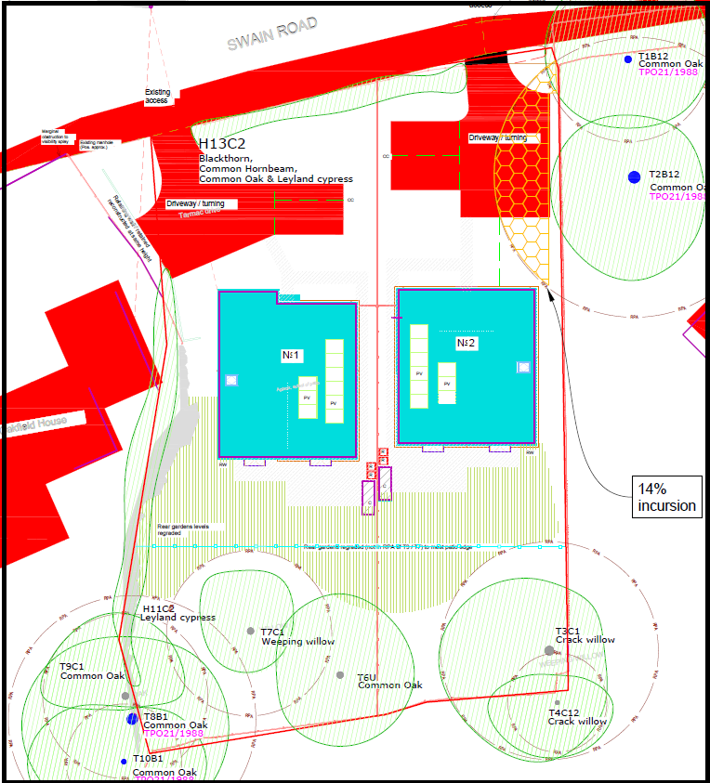

The landscaping scheme trees should be 8-10cm girth and a proactive watering regime of 50l per tree per week May to Sept inclusive should be specified.

My comments on the previous iteration are still relevant in some cases.

My primary concern is the fact that a replacement oak for the dead T6 is not specified within the landscaping plan or the arboricultural report and should be. Without the specific reference we may be accepting the effective loss of the TPO tree an 8-10cm girth oak should be specified as a replacement tree. The planting plan and report should be updated to reflect this amendment.

Species selection suggestion:
- Swap out Sorbus aria for S. torminalis
- Plant both hornbeam and BP on the southern boundary – BP are not long-lived – there is too much reliance on BP through the scheme.
- A hornbeam hedge would also improve the planting offer to the rear (southern) boundary.

Whilst I note that canopy covers a significant section of the garden of Plot 4, I accept that T3 is proposed for pollarding and as a result it will cover less of the garden area. I would request that the proposed pollarding is agreed to be undertaken prior to occupation to make the garden fit for use. A 4-5m pollard may make the tree a better prospect for long-term retention.

Disclaimer:

These are the views of the Placemaking Team Tree Officer as a non-statutory consultee. They represent a material planning consideration in the decision-making process although it is acknowledged that the comments relate to a specific specialism and that there will be other material considerations that need to be weighed up in coming to a decision on the application.

